**ADVANCE SYSTEMS PROJECT**

# House Rental Systems

Submitted By: Dimple Sharma Subhash (700745940)

Department of Computer Information Systems

Course: CIS

Instructor: Dr. Silvana Faja

University of Central Missouri

**Abstract**

Housing Rental Systems is a software company with over 50 employees. The application helps to find the available houses on rental basis.

The app aims to improve the search and ease of access through the following features:

**Admin** can login with username and password and can also see the agent information, can see all the listings posted to the website. The admin can also list the top 20 properties and view the properties listed by a specific agent.

**New Users** can register and login to the application, view all the properties listed in the home page of the website, look at the information and property policies.

**Existing Users** canlogin to the application. Select from the given options and submit a query about the listings in the page or to get the owner details.

**Agent** canlogin with username and password, view the requests received from user regarding the listing or owner details. Can update the listings like add, modify and delete listings based on their availability.

The website utilizes HTML, CSS inline for the front end visualization. JavaScript and PHP for scripting. MySQL database for queries and data storage, retrieval, updating and deletion.

The frontend allows users and agents to login, view the rental property updates, information, modifications and update status in real-time. The MYSQL database of PhpMyAdmin saves the data for CRUD operations on admin, agent, listings, inquiry and users.

This architecture allows building a feature-rich application that meets Housing Rental Systems requirements. The priority is having an intuitive user experience for admins, users and agents.

**TABLE OF CONTENTS**

1. Introduction

1.1 Problem Statement

1.2 Project Description

2. System Requirements

2.1 Environment

2.2 Technological Stack

3. Functional Modules

4. System Design

5. Modeling Diagrams

5.1.1 E-R Diagram

5.2 UML Diagram

5.2.1 Use Case Diagram

5.2.2 Class Diagram

5.2.3 Flow Chart

5.2.4 Sequence Diagram

6. Deployment Process

7. Conclusion

### 1. **Introduction**

**1.1 Problem Statement:**

In today’s fast paced rental market, finding and managing properties is often fragmented and inefficient. The proposed house rental system website aims to streamline the rental process by offering detailed property listings, efficient communication, and seamless appointment scheduling. It will cater to three user roles: admins (who manage the platform), users (potential tenants), and agents (property managers). The system will feature role-based access control, ensuring users have appropriate permissions. Advanced search filters and a user-friendly interface will make property searching easy. Integrated messaging and scheduling tools will facilitate quick interactions. Optimized for performance and scalability, the platform will handle a large number of listings and users, enhancing the rental experience and operational efficiency.

**1.2 Project Description:**

Housing Rental Systems is a software company with over 50 employees. The application helps to find the available houses on rental basis.

The app aims to improve the search and ease of access through the following features:

**Admin** can login with username and password and can also see the agent information, can see all the listings posted to the website. The admin can also list the top 20 properties and view the properties listed by a specific agent.

**New Users** can register and login to the application, view all the properties listed in the home page of the website, look at the information and property policies.

**Existing Users** canlogin to the application. Select from the given options and submit a query about the listings in the page or to get the owner details.

**Agent** canlogin with username and password, view the requests received from user regarding the listing or owner details. Can update the listings like add, modify and delete listings based on their availability.

The website utilizes HTML, CSS inline for the front end visualization. JavaScript and PHP for scripting. MySQL database for queries and data storage, retrieval, updating and deletion.

The frontend allows users and agents to login, view the rental property updates, information, modifications and update status in real-time. The MYSQL database of PhpMyAdmin saves the data for CRUD operations on admin, agent, listings, inquiry and users.

This architecture allows building a feature-rich application that meets Housing Rental Systems requirements. The priority is having an intuitive user experience for admins, users and agents.

### **2. System Requirements**

**2.1 Environment**

**Operating System:** This project is developed on a Windows system, although the code is

**Java:** Java 8 or later is the primary programming language used in this project.

**2.2 Technological Stack**

**Frontend:**

HTML

Javascript

CSS (Inline)

**Backend:**

PHP

**Database:**

MySQL

**Development Environment:** Notepad, Notepad++, php MyAdmin

**3. Functional Modules**

**Admin**

Login

Agent

Listings

Filter listings

**Agent**

Register

Login

Update listings

View inquiries

**Users**

Register

Login

View listings

Send enquiries

Logout

**4. Design Process:**

The developer handles and maintains the design the process In this manner. The files associated with the website are created inside the htdocs subfolder of our project folder

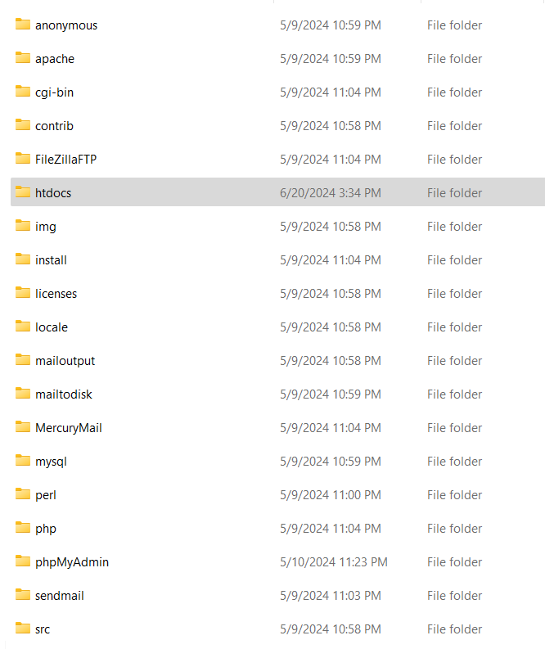

Separate sub folders like admin, agent and user consists of the files related to the three roles we designed in our “Ourhomes” project.

### 

### 5. Modeling Diagrams:

**5.1.2 E-R Diagram:**

**5.2 UML Diagrams:**

**5.2.1 Use Case Diagram:**

**5.2.2 Class Diagram:**

**5.2.3 Flow Chart:**

Admin Login:

Agent Login:

User Login:

**5.2.4 Sequence Diagram:**

**Description:**

Admin logs into the website and views the agents, properties and top property listings based on the rating. Admin when clicks on the agent’s name can see the properties listed by that agent.

**Login Process:**

Initially, the admin, agent and user interact with the webpage to login to the system.

The session storage variables validate the login credentials provided by the user/ admin/ agent.

Based on the authentication response, the system either logs the user into the system or gives an error message.

**Actions Based on User Roles:**

Admin is responsible to view the agent details, their property listings, to check on the trend with the top properties listed.

Agent can register, login to the website and add, modify and delete a listing that he/ she owns. One can view the inquiries that sent by the customer regarding a particular listing.

An user can register, login, view all property listings and after logging in can have the option to send and enquiry regarding any property or agent details.

**Logout Process:**

Each user of the website can logout from their session. This step implements the security and provides the integrity of the data.

**Database Setup:**

We need to install phpMyAdmin and login as the root user. Then import the sql queries and the sample data used in the project.

**Frontend Development:**

Use Notepad++ to view the code files and any web browser to open the URLs to load the website.

**6. Deployment Process:**

**Manual Deployment:**

Download and install xampp from the website :

[**https://www.apachefriends.org/download.html**](https://www.apachefriends.org/download.html)

Save it to the C drive on the system and include the whole project folder inside the htdocs folder.

Start the Xampp and once it is running, we need to start Apache and MYSQL as shown below

Now we need to login to the URLs for agent or admin or as a user.

Admin: <http://localhost/Ourhomes/admin/login.php>

Agent: <http://localhost/Ourhomes/user/view_listings.php>

User: <http://localhost/Ourhomes/agent/login.php>

Then using the sample test data credentials one can login and view the listings and agent data.

### 

### 7. **Conclusion**

Using PHP and phpMyAdmin to create a real estate website provides a stable and adaptable way to handle properties, agents, and customer relations. The advantages, difficulties, and recommended procedures for integrating these technologies into the development process are outlined in this conclusion.

**Scalability and Flexibility**:

A strong server-side scripting language for dynamic content and intricate features needed in a real estate application is PHP.  
Database administration is made simpler with phpMyAdmin, which facilitates handling the structured data associated with user roles, transactions, and property listings.

**Role-Based Access Control**:

Establishing discrete roles, like Administrator and Agent, guarantees a system that is both secure and well-organized. Agents concentrate on property management and client relations, while administrators have the ability to supervise and administer the entire platform.  
The website's operational efficiency and security are improved by this function separation.

**Efficient Data Management**:

Effective data storage and retrieval is made possible by using MySQL databases with phpMyAdmin, which is essential for handling massive amounts of transactional data, user data, and real estate listings.  
The user-friendly interface of phpMyAdmin makes database tasks like making tables, executing queries, and preserving database integrity easier.

**User-Friendly Features**:

Because PHP can interact with HTML and JavaScript, user-friendly interfaces may be created that make it easy for clients to find properties, get in touch with agents, and carry out other tasks.  
Features that improve user experience and engagement include contact forms, maps, and property filters.

**Cost-Effectiveness**:

Both PHP and phpMyAdmin being open-source, provides a cost-effective solution without any compromise on quality or performance. They are suitable for startups and small to medium-sized enterprises in the real estate sector.